NETFLIX CONTENT ANALYSIS
POWER BI PROJECT
DETAILED PROJECT DOCUMENTATION
Submitted By:
Gunda Swapthika
Trainer Name:
Mangali Rakesh
Tool Used:
Microsoft Power BI
Dataset:
Netflix Titles Dataset

INTRODUCTION
Netflix is one of the largest digital entertainment platforms, offering a wide variety of movies and television shows. The large amount of content available in a streaming platform creates an opportunity for data analysis. In this project, a Netflix titles dataset is analyzed using Microsoft Power BI to understand the characteristics and distribution of the available content.
The project starts with a structured Netflix dataset containing title-level information. The data includes fields such as title, type, country, release year, rating, duration, director, cast, genre/category, date added, and description. These fields can be used to answer practical questions about the content catalog.
Power BI is used to transform the raw data into meaningful visual information. Different charts, KPI cards, and an interactive dashboard are used to make the analysis easy to understand. The final dashboard provides a summarized view of Netflix content and allows users to compare different dimensions of the dataset.
This project also demonstrates a complete basic data-analysis workflow: obtaining a dataset, checking and preparing the data, creating calculations, designing visualizations, identifying insights, and presenting the results in a professional dashboard.

PROJECT OBJECTIVE
The main objective of this project is to analyze Netflix content and convert the raw dataset into useful information through Microsoft Power BI. The project is designed to improve understanding of data preparation, visualization, dashboard design, and data-driven decision making.
- To understand the structure and contents of the Netflix titles dataset.
- To analyze the number of Movies and TV Shows available in the dataset.
- To identify the most common content ratings.
- To study the distribution of Netflix content across genres and categories.
- To identify countries with a high number of Netflix titles.
- To analyze how Netflix content is distributed across release years.
- To create summary KPI cards for important metrics.
- To create interactive and easy-to-understand charts.
- To develop a professional one-page Power BI dashboard.
- To generate meaningful insights that can be presented in a project report and presentation.
The project therefore combines technical Power BI skills with analytical thinking. The final result is intended to provide a clear overview of the dataset rather than simply displaying raw records.

DATASET
The Netflix Titles dataset used for this project contains 8,807 records and 12 columns. The dataset provides title-level information about movies and TV shows. The uploaded dataset was used as the source for the analysis and Power BI dashboard.
The fields describe different aspects of each title. For example, the type field identifies whether a record is a Movie or TV Show, release_year identifies the original release year, rating provides the content rating, and listed_in contains genre or category information.
Field | Description
show_id | Unique identifier for a Netflix title
type | Content type: Movie or TV Show
title | Name of the title
director | Director information
cast | Cast information
country | Country or countries associated with the title
date_added | Date when the title was added to Netflix
release_year | Original release year
rating | Content rating
duration | Movie duration or number of TV seasons
listed_in | Genre or category information
description | Description of the title
The dataset is suitable for exploratory analysis because it contains both categorical and numerical fields. These fields can be combined to create comparisons, distributions, trends, and summary measures.

TOOLS AND TECHNOLOGIES USED
Several tools and features are used in the project to move from the raw dataset to the final dashboard. Each tool has a different role in the workflow.
Tool / Feature | Purpose
Microsoft Excel / CSV | Used as the source data file containing the Netflix titles dataset.
Microsoft Power BI | Used to import data, create visuals, build the dashboard, and present insights.
Power Query | Used for data preparation, transformation, checking values, and preparing fields.
DAX | Used where calculated measures or analytical calculations are required.
Power BI Visuals | Used to create cards, bar charts, donut chart, treemap, and trend chart.
The combination of these tools supports a complete business-intelligence workflow. The source file provides the raw information, Power Query prepares it, Power BI performs the visual analysis, and the final dashboard communicates the results.

DATA CLEANING AND TRANSFORMATION
Data cleaning is an important stage before creating visualizations. Raw datasets may contain missing values, inconsistent formats, or fields that need to be interpreted correctly. For this project, the Netflix dataset was reviewed and prepared for Power BI analysis.
The main data-preparation activities include:
- Checking the dataset structure and confirming the available columns.
- Reviewing missing values in fields such as director, cast, country, rating, and date_added.
- Checking data types for dates, numbers, and text fields.
- Preparing release_year as a numeric field for year-based analysis.
- Preparing type as a categorical field for Movie versus TV Show comparison.
- Preparing rating for rating-level analysis.
- Splitting multi-value country and genre/category information when individual-value analysis is required.
- Using appropriate aggregation such as count of show_id for title totals.
- Preparing fields so they can be used correctly in Power BI visualizations and filters.
The purpose of these transformations is to make the data consistent and suitable for analysis. Good data preparation reduces errors and helps ensure that the dashboard communicates the dataset accurately.

DATA ANALYSIS
After preparing the dataset, the next stage is exploratory analysis. The analysis focuses on content volume, content type, ratings, genres, countries, and release-year patterns.
Key dataset measures calculated from the uploaded file are:
Measure | Result
Total titles | 8,807
Movies | 6,131 (69.62%)
TV Shows | 2,676 (30.38%)
Distinct ratings | 17
Distinct countries | 127
Distinct genre/category values | 42
Earliest release year | 1925
Latest release year | 2021
The dataset contains 6,131 Movies and 2,676 TV Shows. Movies make up approximately 69.62% of the records, while TV Shows make up approximately 30.38%.
The release-year data ranges from 1925 to 2021. The year with the highest number of titles in the dataset is 2018, with 1,147 titles.

VISUALIZATIONS
The dashboard uses multiple visualization types so that different questions can be answered quickly. Each visual has a specific analytical purpose.
- KPI cards: Display total titles, ratings, genres, start year, end year, and locations.
- Donut chart: Compares the proportion of Movies and TV Shows.
- Genres bar chart: Shows the leading genre/category values by title count.
- Ratings bar chart: Shows how titles are distributed across content ratings.
- Top countries treemap: Provides a visual comparison of the leading countries by title count.
- Release-year trend chart: Shows how the number of Movies and TV Shows changes across release years.
- Filters: Allow the user to focus the analysis on selected values where applicable.
Together, these visuals provide both a high-level summary and detailed comparisons. The dashboard is designed so that a viewer can understand the overall content mix first and then explore specific dimensions such as rating, genre, country, or year.

POWER BI DASHBOARD
The completed dashboard presents the Netflix analysis on a single report page. It uses a dark background with consistent visual cards and red title styling to provide a Netflix-inspired appearance.
The top section contains KPI cards for major summary values. The middle section contains charts for genres, Movies versus TV Shows, and ratings. The lower section contains the top-country treemap and the release-year trend chart.
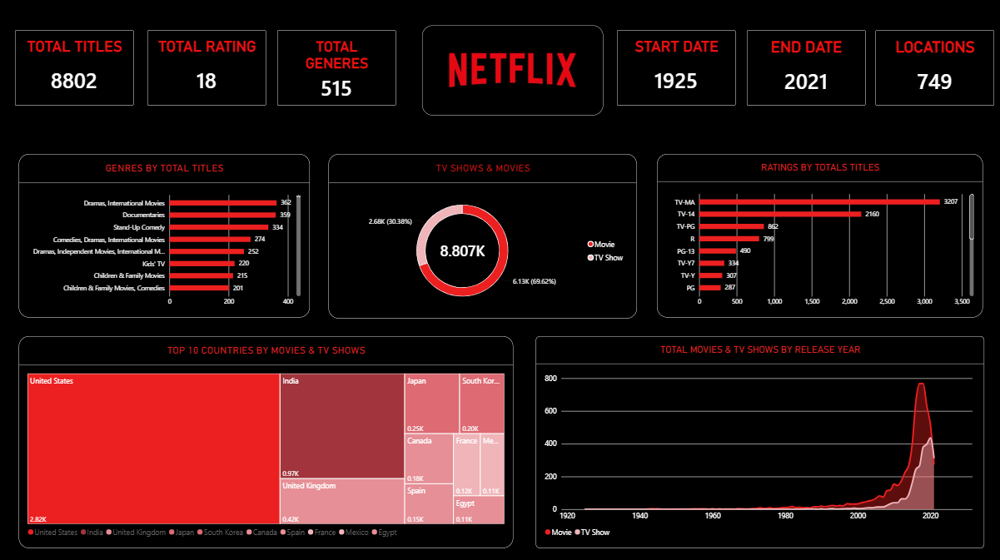
The dashboard is intended to provide an interactive overview rather than a list of raw records. Users can use visual interactions and filters to explore different portions of the dataset.

KEY INSIGHTS
The following insights are derived from the uploaded Netflix dataset and are reflected in the dashboard analysis:
- The dataset contains 8,807 total Netflix titles.
- Movies are the majority of the dataset with 6,131 titles, representing 69.62% of all records.
- TV Shows account for 2,676 titles, representing 30.38% of all records.
- TV-MA is the most common rating, with 3,207 titles.
- TV-14 is the second most common rating, with 2,160 titles.
- International Movies is the most frequent individual genre/category value, with 2,752 titles.
- Dramas is the second most frequent individual genre/category value, with 2,427 titles.
- The United States has the highest individual country count at 3,689, followed by India at 1,046.
- The release-year range in the dataset is 1925–2021.
- The largest single release-year count is 1,147 titles in 2018.
These insights help summarize the major characteristics of the dataset and demonstrate how visual analytics can convert thousands of records into a small number of understandable findings.

CONCLUSION
The Netflix Content Analysis project demonstrates a practical application of Microsoft Power BI for data analysis and visualization. A Netflix titles dataset was prepared and analyzed to understand the distribution of content by type, rating, genre/category, country, and release year.
The dashboard provides a compact view of the dataset through KPI cards and multiple visualizations. The analysis shows that Movies form the larger part of the dataset, while ratings, countries, genres, and release years provide additional dimensions for understanding the content catalog.
This project demonstrates important skills including dataset understanding, data cleaning, Power Query transformation, analytical calculations, visual selection, dashboard formatting, and insight generation. The final result can be used as an academic project, portfolio project, or demonstration of beginner-to-intermediate Power BI skills.
Future improvements could include adding more advanced DAX measures, interactive slicers, drill-through pages, tooltip pages, additional time-based analysis, and more detailed content-level analysis.

PROJECT SUMMARY
Project Name: Netflix Content Analysis
Dataset: Netflix Titles Dataset
Dataset Size: 8,807 rows × 12 columns
Primary Tool: Microsoft Power BI
Supporting Tools: Power Query, DAX, Excel/CSV
Main Deliverables: Dataset, Power BI Dashboard, Project Document, Presentation (PPT)
Main Analysis Areas: Content Type, Rating, Genre/Category, Country, Release Year
Dashboard Status: Completed
This document is organized so that each major topic starts on a separate page. It can be used as the written documentation for the Power BI project.

Github Link :
https://github.com/Gundaswapthika/Netflix-Content-Analysis-PowerBI

